**Elephant - Wooden Animal Wall Mount**

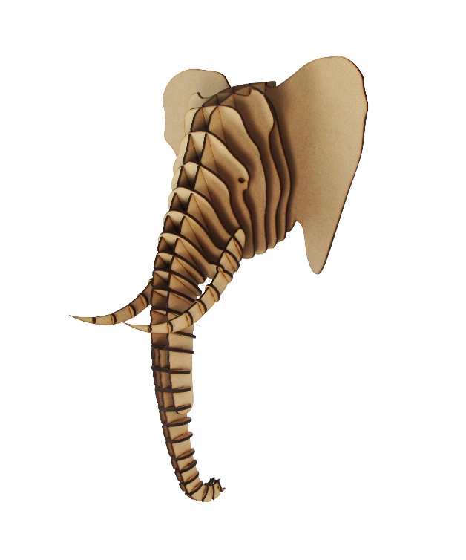The Elephant Wooden Animal Wall Mount is a bold and elegant decorative piece that brings a sense of grandeur and nature into your space. Crafted from high-quality wood, this mount features a beautifully detailed elephant head, showcasing intricate carving and texture that capture the majesty of the animal. The rich, natural tones of the wood add warmth and an organic touch to any room, while the design’s simplicity and refinement make it suitable for both rustic and modern interiors. Perfect for those with a love for wildlife and unique, eco-friendly decor, this elephant mount serves as a stunning focal point.